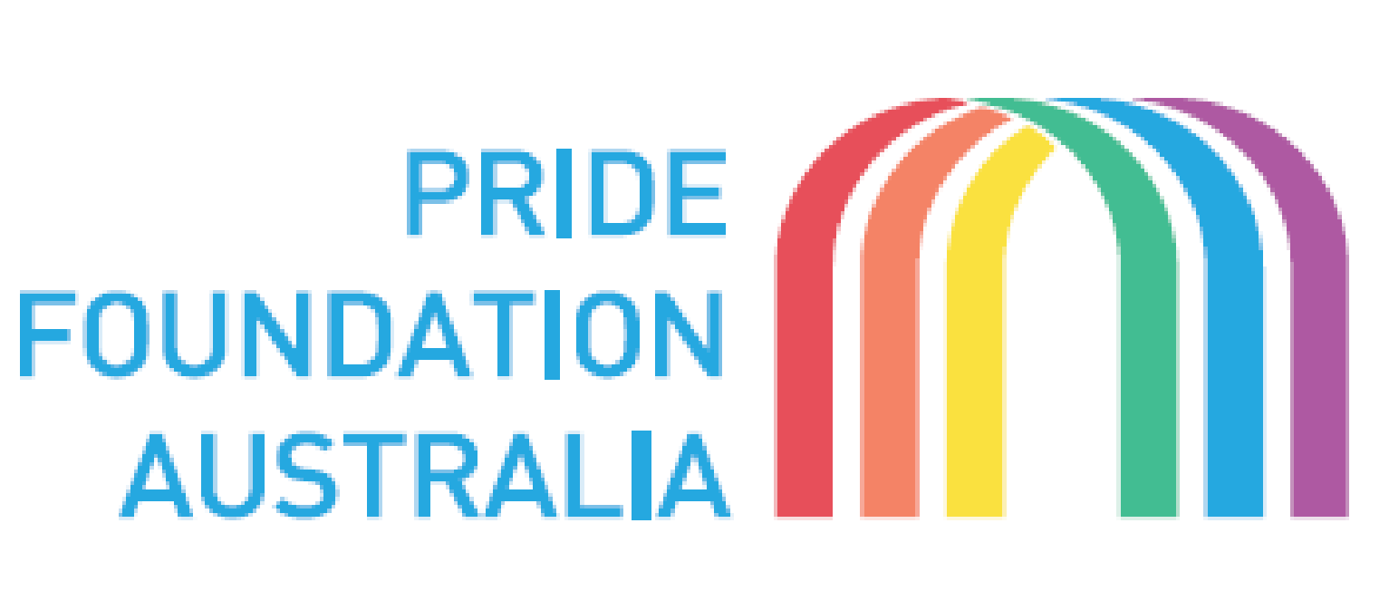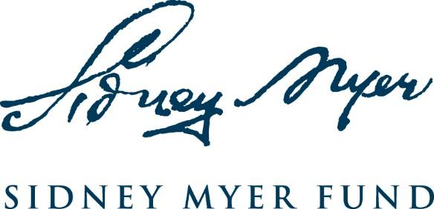

Pride Foundation Australia - Sidney Myer Foundation funding round
Expression of Interest form

Form to be completed in no more than three pages

Please send the completed form by email to: grants@pridefoundation.org.au

Closing date for expressions of interest: Friday 16 August 2019, 5pm EST

Applicant details

Name of Organisation: | Organisation ABN:  Organisation ACN:
Address: | Web address:
Contact Person and Position:
Phone Number: | Mobile phone:
Email:

Does the organisation have DGR status? Yes No
If no, please provide details of the partnering organisation:

Partner Organisation details

Name of Organisation: | Organisation ABN:  Organisation ACN:
Address: | Web address:
Contact Person and Position:
Phone Number: | Mobile phone:
Email:

The proposal

- The project title

- Please indicate one or more areas regarding LGBTQIA+ people living with a disability to be addressed in the project:

 | Reducing isolation |  | Building evidence
 | Recognising multiple identities |  | Enhancing cultural engagement
 | Building community capacity |  | Improving LGBTQIA+ inclusive practice in services

- Brief background of the project – evidence of why it is needed (up to 100 words)

- Brief project description – what it is about (up to 100 words)

- Brief description of the project and activities to be undertaken (up to 100 words)

- Expected outcomes – what you will achieve (up to 100 words)

- Total amount requested from PFA-Sidney Myer Fund (up to $20,000)
$

